EVC stuck in preparing mode

Author:胡维
Reviewer：Eason
FAQ/EVC
Issue introduction:
EVC is stuck in ‘preparing’. EVC doesn’t charge immediately after plugging in the EV plug.
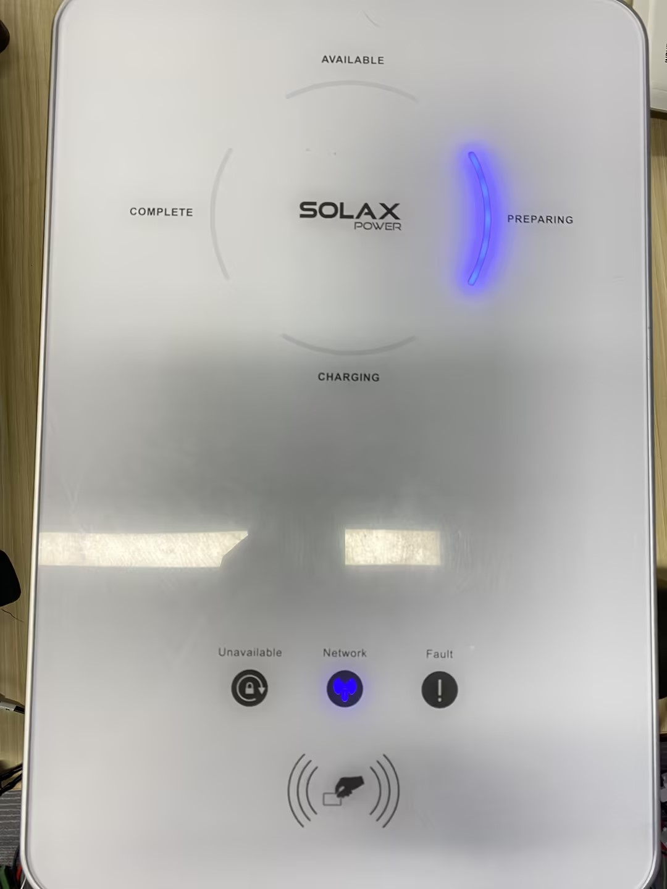
Confirmation of basic information：
[Photo] SN numbers of the EVC and inverter
Guidance for installer
Step 1:Check the work mode. If the EVC is in the green mode (the current standard from PV can be setat 3A/6A), and energy from PV side is insufficient to start the EVC it cannot charge.
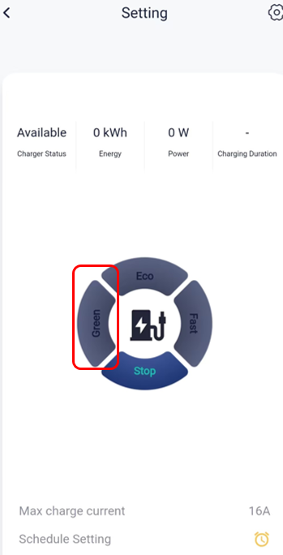
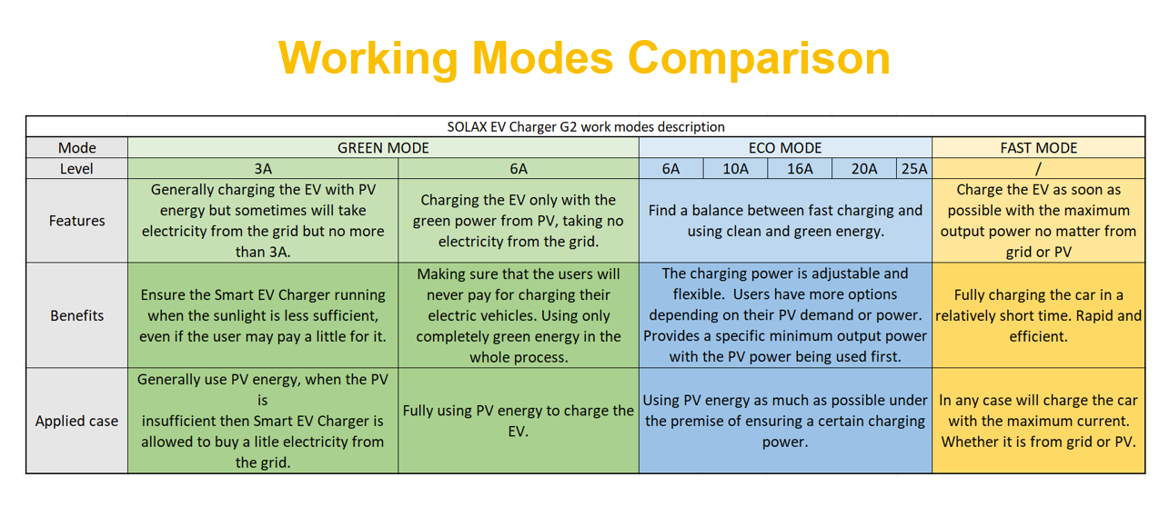
If the energy from PV has already met the demand of Green Mode, check the communication connection between the inverter and EVC.
Situation1<for EVC connected to inverter >
Confirm the mailing address, and baud rate should be the same as the value set by EVC,The image shows an example of the EVC connected to the X3 Hybrid G4
Setting Path(for inverter): Settings→Advanced Setting→Modbus
Setting Path(for EVC):Setting→Charger Setting
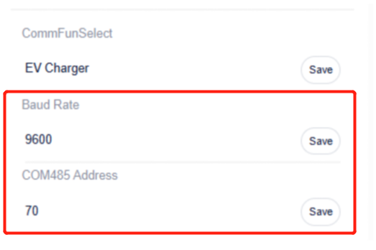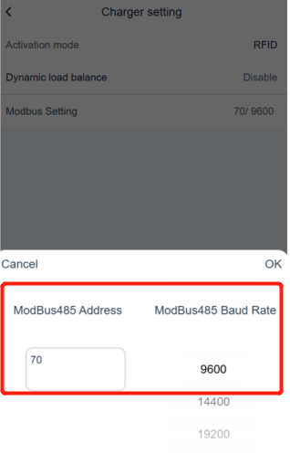
And the CommFunSelect on the inverter should correspond to the Grid Data Source of the EVC.
Setting Path(for inverter): Settings→Advanced Setting→Modbus→CommFunSelect
Setting Path(for EVC): Device→EV Charger→Advanced Settings→Grid Data Source
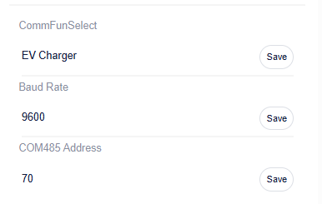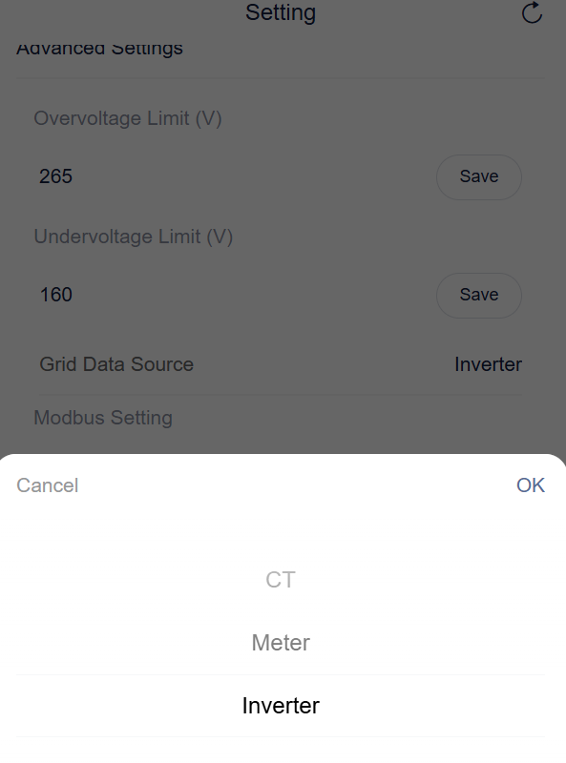
Situation2<for EVC with Meter/CT which connected to grid connection point>
Check the ‘Grid Data Source’ in Solax Cloud System and select it according to the actual situation.
Setting Path: Device→EV Charger→Advanced Settings→Grid Data Source
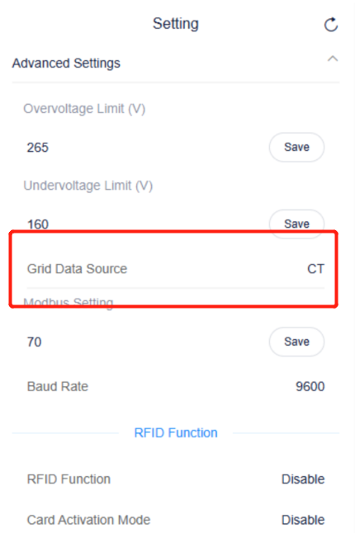
For Home version, confirm the type of sample device being used. If it uses a Meter, the communication line should be connected to terminals RJ45.
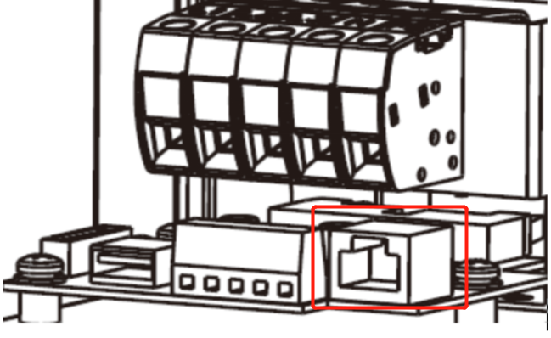
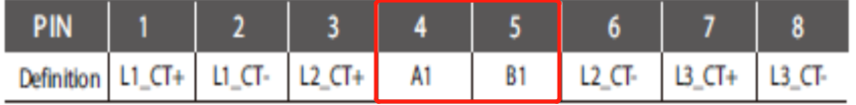
If it uses CT, the communication line should be connected to terminals RJ45, ensuring that the pins correspond to the connections shown in the figure.


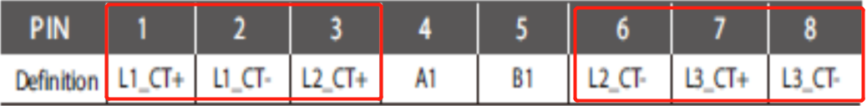
For Fusion version, it can only use CT because of the terminals, connect the communication line to the terminal named INV/CT.
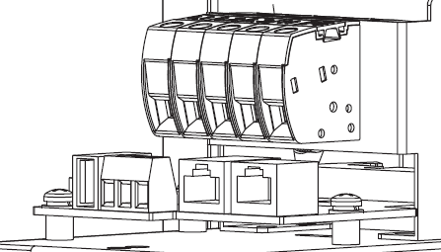

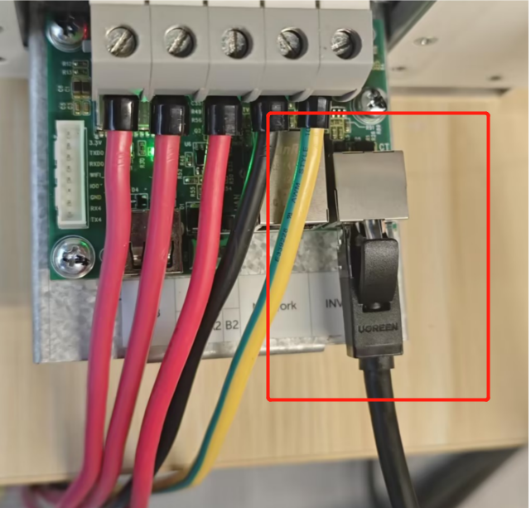
Step 2: If RFID Function is enabled, the card must be swiped before use, and if the EVC does not work after swiping the card, check the inverter function refer to the following methods.
For Home version charger:
If the EVC does not work after swiping, try to disable the RFID function, then restart the EVC and re-plug it.
Settings path: Advanced setting → RFID function
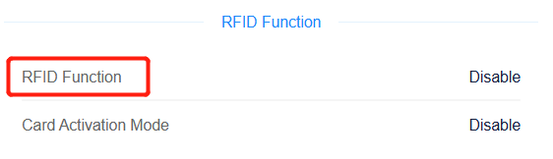
For Fusion version charger:
Choose the Plug&Charge, it can charge immediately. Check the activation mode using the following path:
Upper right corner Setting Options->Setting->Charger Setting->Activation Mode
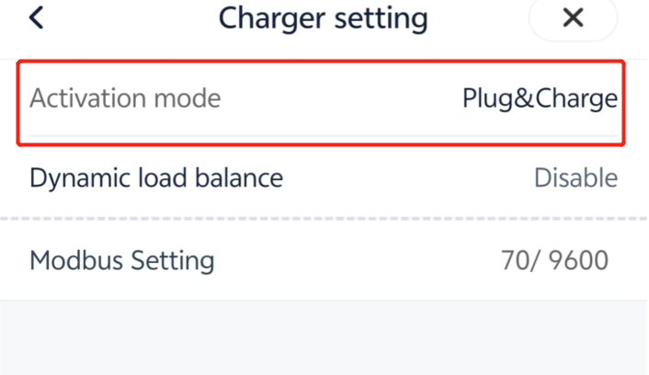
Step 3: When the Restrictive Activation is on, the EVC cannot charge or discharge due to the safety code from different country. If the EVC is needed to work, just check the relevant charging restrictions before setting EVC and switch off Restrictive Activation. Note: Home Version doesn’t have Restrictive Activation.
The guide to setup is as follows:
Upper right corner Setting Options->Setting->Advanced Setting->Charging Restriction

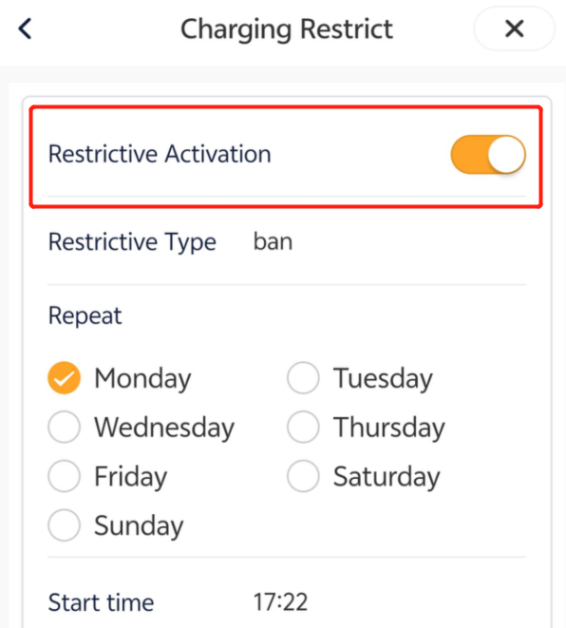
Step 4:View the Random charge delay function. This function works to protect the main circuit, and may delay the starting time of the charging pile. If the number of charging piles in the same power station is relatively small, you can choose to disable this function.
Setting Path: Top right corner setting option->Setting->Advanced Setting->Random charging delay.
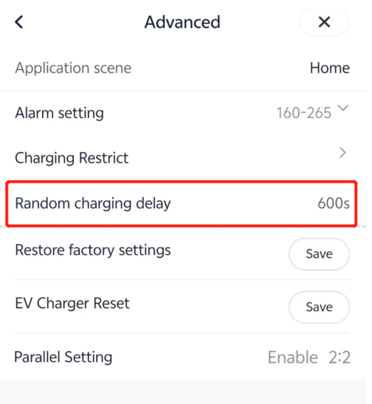
Information Select list:
If you have completed the above <Guidance for installer>, and the problem is still not solved, please collect the following troubleshooting information and send them to the R&D.

1.[Photo] SN numbers of the EVC and inverter.
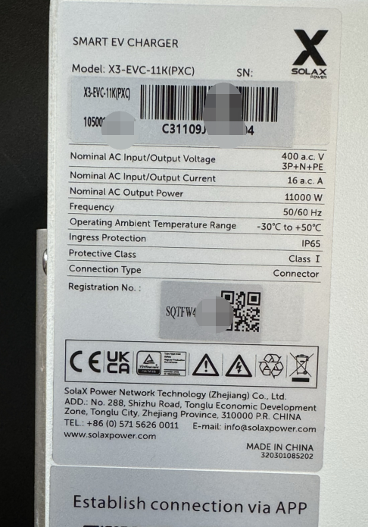
2.The wiring connection and its’ work mode
3.The baud rate and address of inverter and EVC
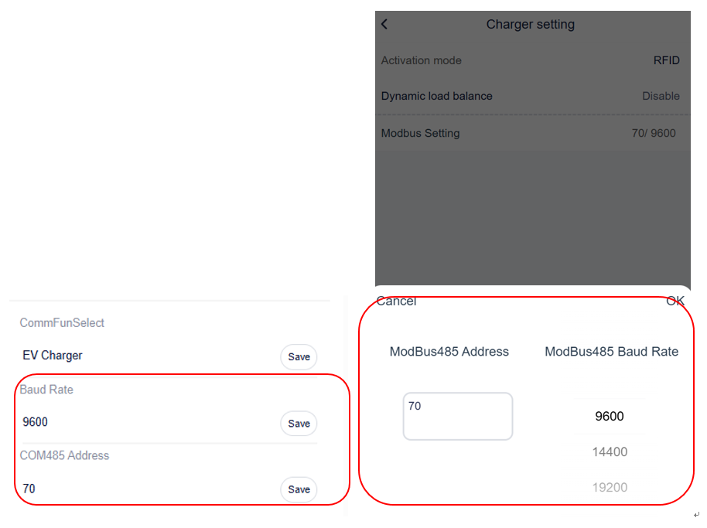
4.The selection of inverter and EVC
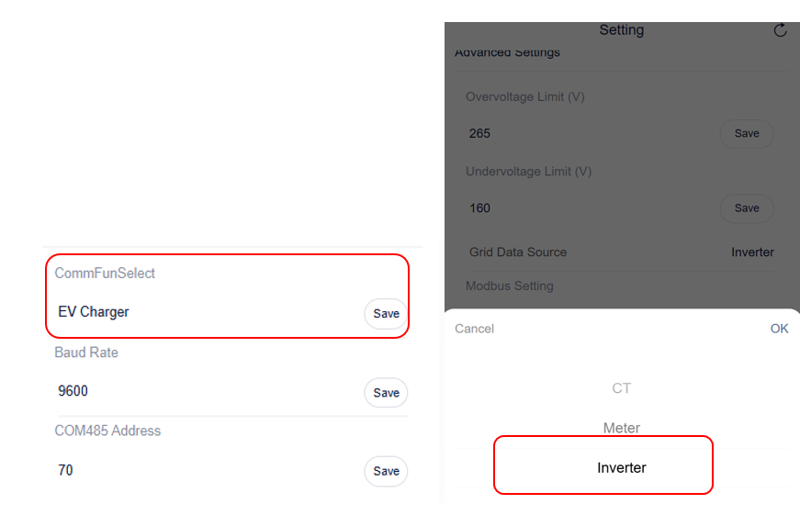
5.The Activation mode.
6.The Restrictive Activation settings.

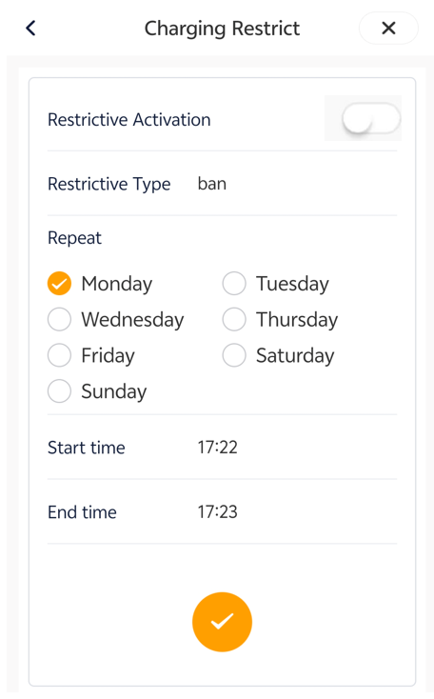
- The random charging delay settings.
